**Software Developer Course Assessment**

**Quantitative Assessment Practice**

**Course Name: Advanced Programming (Java)**

**Current Week: 13th September 2024**

**Submission date: 24th September 2024**

**Introduction:**

The purpose of this assessment is to help us understand how the class is doing in terms of the review material that we have covered during the previous couple of weeks. The **only** purpose of this assessment is for us to improve our approach to review and ensure that what we’re currently doing is an effective strategy. Completion of this assessment is **mandatory - if you don’t submit a solution, it will be marked as incomplete. You must complete a minimum of 80% of your assigned QAPs per course – otherwise you will be marked as incomplete for that course no matter how good your other grades are.** If you do submit a solution, it will be marked as complete, as you will receive full marks no matter what your actual performance was – again this is a participation grade.  
  
Again, the goal here is to help you all in the best way that we can, so please do be honest when answering the questions related to how long it took, which resources you used, etc. And please ensure that you do your **own** work – don't just copy off a friend to get it done, earnestly do your best with it. If you can’t get it completely working, give us what you have. While it will be graded, the grade will not count against you, it’s just a way for us to see where everybody is, and to know which concepts, if any, we, as a class, may be struggling with.

**Deadline:** You will have until the end of the day on 24th Sep 2024 to submit your assessment solutions. Please ensure you answer all the questions outlined in the instructions portion of this document as well in your submission.

**Marking:** In this program core evaluation is marked with one of three possible marks: *Incomplete, Pass, Pass Outstanding.* For QAPs, though, where incomplete marks are more important for our own information as well as for the information of the student, we wanted to increase the resolution of our grading system. Therefore, QAPs are marked on a scale of 1-5. The details of this marking system are summarized in the table below.

|  |  |
| --- | --- |
| **Grade** | **Meaning** |
| 1 | *Incomplete.* Student shows severe lack of understanding of the material – solution is heavily incomplete, non-functional, or completely off base of what the assignment was asking for. |
| 2 | *Partially Complete.* Students show some understanding of the material. Solution may be non-functional or partially functional, but the approach is correct, albeit with some major bugs or missing features. |
| 3 | *Mostly Complete.* Student demonstrates understanding of the major ideas of the assignment. Solution is mostly working, albeit with a few small bugs or significant edge cases which were not considered. Shows a good understanding of the correct approach, and is either nearly a feature-complete solution, or is a feature-complete solution with some bugs. |
| 4 | *Complete (Equivalent to: Pass.)* Student shows complete understanding of assigned work and implemented all necessary features. Any bugs that are present are insignificant (for example aesthetic bugs when testing the functionality of code) and do not impact the core functionality in a significant way. All necessary objectives for the assignment are completed, and the student has delivered something roughly equivalent to the canonical solution in terms of features and approach. |
| 5 | *Complete with Distinction (Equivalent to: Pass Outstanding)* The student demonstrates a clear mastery of the subject matter tested by the QAP. The solution goes above and beyond in some way, makes improvements on the canonical solution, or otherwise demonstrates the student’s mastery of the subject matter in some way. A solution in this category would consider all reasonable edge cases and implement more than the necessary functionality required by the assignment. |

**Instructions:**

You are allowed to complete the assessment problems below in whatever way you can but please answer the following questions/points as part of your submission:

1. How many hours did it take you to complete this assessment? (Please keep try to keep track of how many hours you have spent working on each individual part of this assessment as best you can - an estimation is fine; we just want a rough idea.)

[It took me around 2 hours to complete]

1. What online resources you have used? (My lectures, YouTube, Stack overflow etc.)

[I used class notes only. Looked up on the internet how to make the right format for date and time only]

1. Did you need to ask any of your friends in solving the problems. (If yes, please mention name of the friend. They must be amongst your class fellows.)

[No]

1. Did you need to ask questions to any of your instructors? If so, how many questions did you ask (or how many help sessions did you require)?

[No]

1. Rate (subjectively) the difficulty of each question from your own perspective, and whether you feel confident that you can solve a similar but different problem requiring some of the same techniques in the future now that you’ve completed this one.

[It was an easy QAP and it was not difficult to complete. I will easily solve those problems again]

**Problem#1:**

**The Account Class**

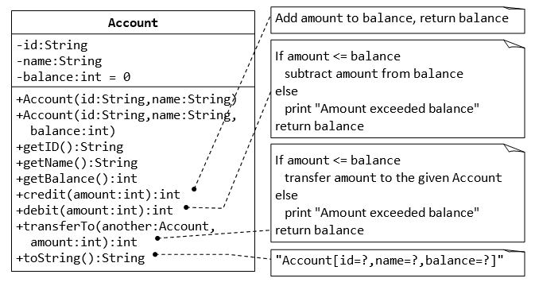

1. Write java code for the Account class explained above. (Account.java)
2. Write a *test program* called TestAccount (in another source file called TestAccount.java) which uses the Account class.
3. Create two accounts
   1. Acc1 with balance of $5000 and Acc2 with balance of $4000 by using parameterised constructors defined in Account class.
   2. Display balance of both accounts using getBalance() method.
   3. Transfer $1000.00 from account 1 to account 2.
   4. Display balance of both accounts using getBalance() method again.

**Deliverable#1:**

*Two complete and working-class files with proper comments.*

1. *Account.java*

package Account;

public class Account {

private String id;

private String name;

private int balance = 0;

// Constructors

public Account(String id, String name){

this.id = id;

this.name = name;

}

public Account(String id, String name, int balance){

this.id = id;

this.name = name;

this.balance = balance;

}

// Gets and Sets

public String getId(){

return id;

}

public String getName(){

return name;

}

public int getBalance(){

return balance;

}

public int credit(int amount){

balance += amount;

return balance;

}

public int debit(int amount){

if (amount<=balance){

balance -= amount;

} else {

System.out.println("Amount exceeded balance");

}

return balance;

}

public int transferTo(Account another, int amount){

if (amount <= this.balance) {

this.balance -= amount; // Deduct from current account

another.balance += amount; // Add to another account

} else {

System.out.println("Amount exceeded balance.");

}

return this.balance;

}

public String toString(){

return "Account: id is " + id + ", name is " + name + ", balance is " + balance + ".";

}

}

1. *TestAccount.java*

package Account;

public class TestAccount {

public static void main(String[] args) {

// Step 2a: Create two accounts

Account acc1 = new Account("001", "Alice", 5000);

Account acc2 = new Account("002", "Bob", 4000);

// Step 2b: Display balance of both accounts

System.out.println("Initial Balances:");

System.out.println("Account 1 (Alice): " + acc1.getBalance());

System.out.println("Account 2 (Bob): " + acc2.getBalance());

// Step 2c: Transfer $1000 from account 1 to account 2

acc1.transferTo(acc2, 1000);

// Step 2d: Display balance of both accounts again

System.out.println("\nBalances after transfer:");

System.out.println("Account 1 (Alice): " + acc1.getBalance());

System.out.println("Account 2 (Bob): " + acc2.getBalance());

}

}

1. *Screenshots of the running code’s output*

**Problem#2:**

**The Date Class**

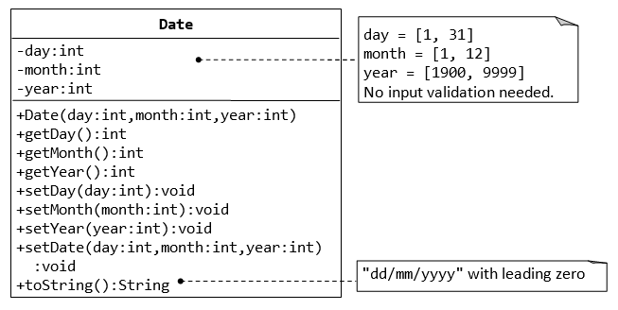

1. Write java code for the Date class explained above. (Date.java)
2. Write a *test program* called TestDate (in another source file called TestDate.java) which uses the Date class.
3. Create a Date object and print it using the toString() method in the format specified.

**Deliverable#2:**

*Two complete and working-class files with proper comments.*

1. *Date.java*

package Date;

public class Date {

private int day;

private int month;

private int year;

// Constructor

public Date(int day, int month, int year) {

this.day = day;

this.month = month;

this.year = year;

}

// Getters and Setts

public int getDay() {

return day;

}

public int getMonth() {

return month;

}

public int getYear() {

return year;

}

public void setDay(int day) {

this.day = day;

}

public void setMonth(int month) {

this.month = month;

}

public void setYear(int year) {

this.year = year;

}

public void setDate(int day, int month, int year) {

this.day = day;

this.month = month;

this.year = year;

}

// To String

public String toString() {

return String.format("%02d/%02d/%04d", day, month, year);

}

}

1. *TestDate.java*

package Date;

public class TestDate {

public static void main(String[] args) {

// Create a Date object

Date date = new Date(15, 9, 2023);

// Print the date using the toString() method

System.out.println("The date is: " + date.toString());

}

}

1. *Screenshot of the running code’s output*

**Problem#3:**

**The Time Class**

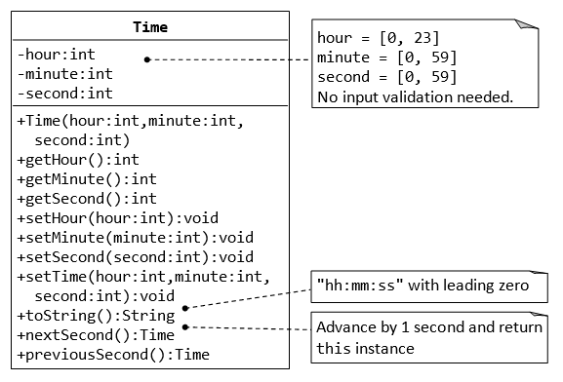

1. Write java code for the Time class explained above. (Time.java)
2. Write a *test program* called TestTime (in another source file called TestTime.java) which uses the Time class.
3. Create a two time objects (t1 and t2). Set their time to 21:10:15 and 10:20:25 using set methods.
4. Call nextSecond() for t1 and previousSecond() for t2.
5. Display the final times for t1 and t2 using toString() method.

**Deliverable#3:**

*Two complete and working-class files with proper comments.*

1. *Time.java*

package Time;

public class Time {

private int hour;

private int minute;

private int second;

// Constructor

public Time(int hour, int minute, int second) {

this.hour = hour;

this.minute = minute;

this.second = second;

}

// Getters and Setts

public int getTime() {

return hour;

}

public int getMinute() {

return minute;

}

public int getSecond() {

return second;

}

public void setTime(int hour) {

this.hour = hour;

}

public void setMinute(int minute) {

this.minute = minute;

}

public void setSecond(int second) {

this.second = second;

}

public void setTime(int hour, int minute, int second) {

this.hour = hour;

this.minute = minute;

this.second = second;

}

// To String

public String toString() {

return String.format("%02d:%02d:%02d", hour, minute, second);

}

// Next and Previous Second

public Time nextSecond() {

int newSecond = second + 1;

int newMinute = minute;

int newHour = hour;

return new Time(newHour, newMinute, newSecond);

}

public Time previousSecond() {

int newSecond = second - 1;

int newMinute = minute;

int newHour = hour;

return new Time(newHour, newMinute, newSecond);

}

}

1. *TestTime.java*

package Time;

public class TestTime {

public static void main(String[] args) {

Time t1 = new Time(21, 10, 15);

Time t2 = new Time(10, 20, 25);

// Display initial times

System.out.println("Initial Time t1: " + t1.toString());

System.out.println("Initial Time t2: " + t2.toString());

// Call nextSecond() for t1

Time nextT1 = t1.nextSecond();

// Call previousSecond() for t2

Time previousT2 = t2.previousSecond();

// Display final times

System.out.println("Final Time t1 after nextSecond: " + nextT1.toString());

System.out.println("Final Time t2 after previousSecond: " + previousT2.toString());

}

}

1. *Screenshot of the running code’s output*

# Submission:

Please create a public github repository and upload all the java files files (Account, Date, Time, TestAccount, TestDate, TestTime), and a word document with the screen shots of all the outputs and their running codes and also the feedback questions. Finally submit the link to that repository.